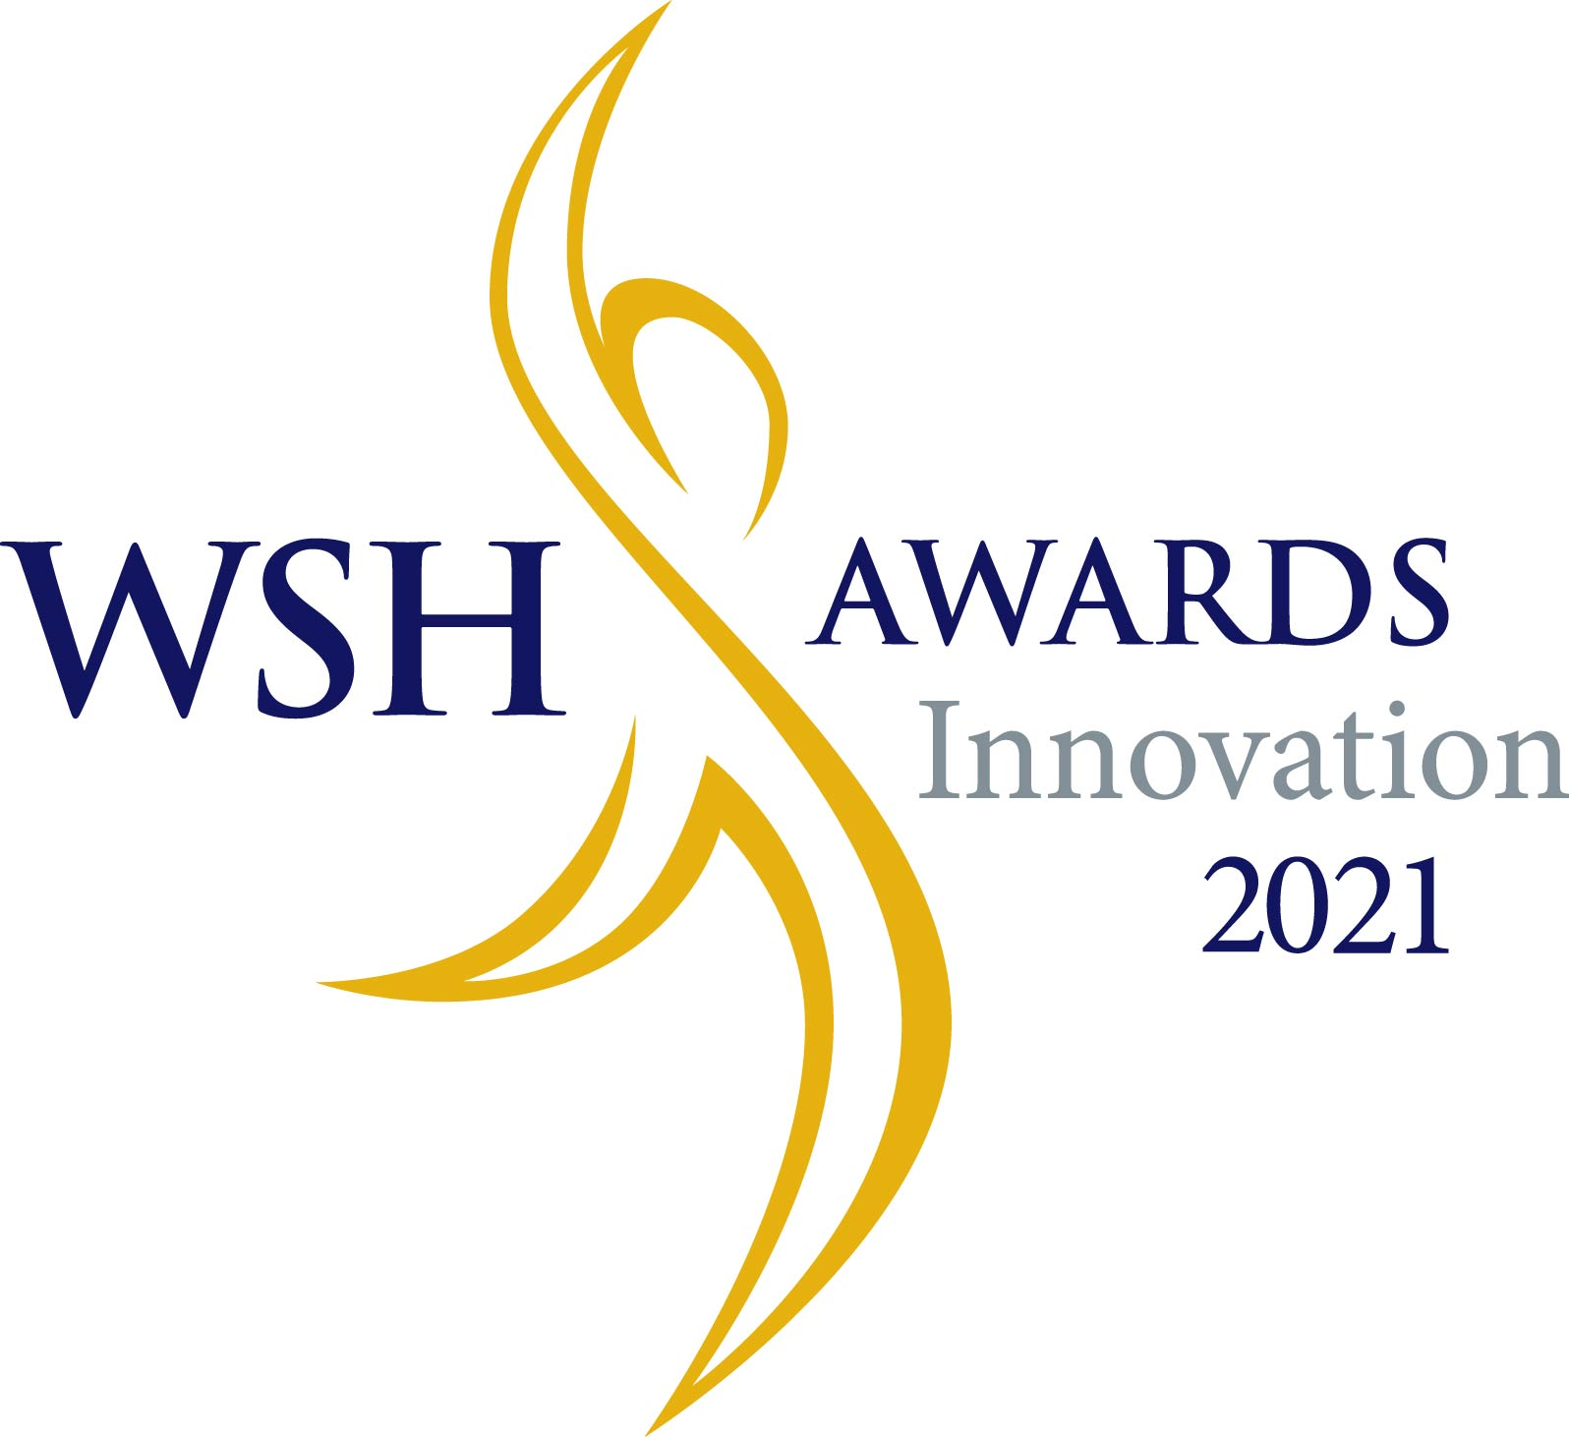

Workplace Safety and Health
Innovation Awards 2021

Guidelines and Application Form

Please refer to Application Guidelines on how to apply for this Award. The respective associations and WSH Council will not process the application if Parts 1 and 2 are not completed and/or the required documents or materials are not submitted in a CD/DVD/Memory Drive or via electronic submission.

Application for
WSH Innovation Awards 2021

Entries for this award are evaluated by the following organisations. Please submit your application to the relevant organisation according to your industry. You may wish to view their websites for more details.

Industry | Submit application to | Details
Construction | The Singapore Contractors Association Ltd  1 Bukit Merah Lane 2, Construction House,  Singapore 159760  Name: Mr Yeo Wei How  Tel: 6661 9380  Email: weihow@scal.com.sg | 7 April 2021
Shipbuilding and  ship repair | Association of Singapore Marine Industries  9 Jurong Town Hall Road  #04-03, Trade Association Hub,  Singapore 609431  Name: Mr Yeo Chow Keong  Tel: 6264 6436  Email: chowkeong.yeo@asmi.com | 18 March 2021
Manufacturing | Singapore Manufacturing Federation  2985 Jalan Bukit Merah  Singapore 159457  Name: Ms Prasunna Ramadas  Tel: 6826 3045  Email: prasunna.ramadas@smfederation.org.sg  Name: Ms Ng Li Kiang  Tel: 6826 3012  Email: likiang.ng@smfederation.org.sg | 7 April 2021
Hotel | Singapore Hotel Association  21 Bukit Batok Street 22, Singapore 659589  Name: Ms Li Shaoting  Tel: 6415 3509  Email: shaoting@sha.org.sg | 7 April 2021
Logistics and Transportation | Singapore Logistics Association  Link for online submission: https://zfrmz.com/YwNZKXdlKMsDquxqwnmi.  Name: Ms Nurliana  Tel: 6499 9799  Email: nurliana@sla.org.sg | 7 April 2021
Process and Chemical | Association of Process Industry  Please contact ASPRI to confirm the preferred mode of submission.  Name: Mr Brandon Liu  Tel: 6560 5051  Email: brandon@aspri.com.sg | 7 April 2021
Others  (eg. Facilities management, waterworks, etc) | Workplace Safety and Health Council  1500 Bendemeer Road, #04-01  Ministry of Manpower Services Centre, Singapore 339946  Name: Ms Melissa Lim  Tel: 6653 3514  Email: wshawards@wshc.sg | 7 April 2021

Criteria for WSH Innovation Awards 2021

- Project led by teams comprising employees.

- Innovative WSH solutions and practices for hazards such as chemicals, noise, work at height, ergonomics etc.

- Applicants must submit effective Risk Control Measures which do not create or lead to new risks that are not well managed.
- Applicants who can show a solution that eliminate the risks and can potentially be translated industry-wide will gain more points

- Resulted in significant improvement in WSH.

- The control solution must have been implemented for at least six months. No reportable solution-related accident/incident in the workplace following implementation of the control solution

- No stop work order, remedial order, composition fine or prosecution for control solution related contraventions in the preceding one year at the time of application.

- Control solutions may be in the form of engineering measures, practices or implementation of safety systems that eliminate or effectively control the hazard and/or significantly reduce the risk.

- The control solution should not introduce new hazards into the workplace. The solution should not also infringe any copyright and/or patent law.

factors for EVAluation

Some of the factors that will be taken into consideration during the evaluation process for the control solution category include:

- Innovation- solutions are to be innovative, sound and practical.
- Comprehensive Protection – how comprehensive/collective the solution is in providing protection to those exposed to the hazard and whether the solution has addressed the risks adequately.
- Ease of set-up and use – how quickly and easily the device could be set up for use to provide the protection.
- Expandability – whether the solution can be built on/modified so that it could be applied to other situations or adapted to increase the protection where required.
- Life cycle cost – whether the cost of the device/solution encourages usage.
- The applicant’s overall safety performance record.
- Effectiveness of the control programme in supporting the successful implementation of the control solution.
- The degree of involvement and participation of the employees (includes contractors) in risk management, and development and implementation of the solution

Bonus Factor: The control solution incorporates Total WSH element/s or uses technology to mitigate/ eliminate the WSH risk

Judging of Projects
Judging will be done at the industry level. Teams can submit their projects under one of the seven categories outlined above for the awards.

A convention will be held for each category for the shortlisted teams to present their projects to a panel of judges. Please refer to Table A for the awarding of points for the competition.

Awards and Prizes
A maximum of 3 winning teams from each association will be nominated for further evaluation to receive the WSH Award on a national platform.

How to apply for the awards (for industry associations)

1. Contact the respective association to confirm the preferred mode of submission.

2. The following documents/materials must be completed and submitted in a CD/DVD/Memory Drive or via electronic submission through e-mail to the associations to support your application:

    - Part 1: General Information of the team

    - Part 2: Project Report (Including pictures of project)

    - Microsoft Powerpoint Slides that includes all scoring factors (except ‘Presentation’) mentioned in Table A in this application form

    - Project report mentioned in Part 2 of this application form

    - Pictures/video of the project to aid the organiser in better evaluation.

Incomplete application will not be processed.

3. Please label the CD/DVD/Memory Drive in the following format:

WSH Innovation Awards 2021
Name of team: _________________________________
Contact Person: _________________________________
Contact No: _________________________________

If the submission is done via e-mail, kindly indicate the above details in your e-mail to us.

4. Print and sign Part 1. Print the report in the format given in Part 2. The report must be filed so that the pages are secured. Do not print the Powerpoint presentation.

Place Parts 1 and 2, and the CD/DVD/Memory Drive in an envelope and submit it to the organisation organising the convention for your industry. Alternatively, you may also e-mail the signed reports and materials to the respective associations. You may want to use a file-hosting service such as Dropbox to send bigger files.

The materials must be submitted to the organiser given on the front page of this application. Please submit to the correct organisation to prevent your application from being delayed. As the closing date for each industry may be different, you might miss the award if you submit to the wrong organiser.

5. Your project will be evaluated by the organisation you submitted your application to. It will select the teams to present before a panel of judges in a convention organised for your industry.

Terms and Conditions

  - Application forms must be correctly filled.
  - Late entries will not be accepted.
  - Application with inaccurate information will be disqualified.
  - Entries must be the team’s original concept over which it has or may have intellectual property rights.
  - Entries which the judges believe to be false or exaggerated or unverifiable will not be selected.
  - WSH Council or MOM reserve the right to publicly revoke an award should we learn of information that, had it been disclosed to the judges, would have materially affected the panel’s decision.
  - All entries are regarded as confidential; however, initiatives of recipients and finalists may be described in summary or in detail at the award presentation, and in any of WSH Council’s, MOM’s and the organisers’ seminars, workshops, or publications (including on the internet).
  - All recipients are expected to work with WSH Council, MOM or the organisations which organised the conventions to help publicise their achievements and agree to participate in publicity activities following the award presentations.
  - An award does not constitute an endorsement by WSH Council or MOM of the applicant’s activities or its product, method or service, or the safety and health performance of its workplace.
  - WSH Council and MOM and the organisers are not responsible for any loss or damage to entries or supporting material.
  - WSH Council, MOM and the organisers will not return any entries or supporting material to the entrant.
  - WSH Council, MOM and the organisers reserve the right to decline an entry where the applicant or organisation is under investigation for possible breach of Workplace Safety and Health Act or Workmen’s Compensation Act (whether a prosecution is pending), or where the acceptance of the entry may be detrimental to the objectives of the Workplace Safety and Health Awards 2021.
  - The decision of the judges is final.
  - There will be no appeal process.
  - To encourage sharing of best practices, recipient of this category will be invited to share the winning project to participants at related events organized by WSH Council.

Where to submit

- Please contact the respective industry associations for submission details.

- For submission to the industry associations, please make an appointment with the respective association prior to submission.

- For submission under ‘Others’ category, please see procedures as follows:

- Complete the WSH Innovation Requisition Form (XLS) (Part 1 of the application form) at https://www.tal.sg/wshc under ‘Awards and Competitions’ and send the completed form to wshawards@wshc.sg.

- Prepare and submit with the following in a CD, DVD or memory drive to the abovementioned representative from WSH Council:

- WSH Innovation Requisition Form (Part 1 of the application form);
- Project report (Part 2 of the application form); and
- Microsoft Powerpoint Slides with videos and pictures.

Submit the application to:

WSH Innovation Awards 2021
Workplace Safety and Health Council
1500 Bendemeer Road, #04-01
Ministry of Manpower Services Centre
Singapore 339946

Attention: Ms Melissa Lim

- The application must reach us by 7 April 2021. Do not submit the application on Saturdays or Sundays.

TABLE A:
Awarding of Points for the Competition (may vary slightly amongst the industries)

ITEMS | EVALUATION CRITERIA (recommended scores)
Project  Selection and Problem Definition  (15 Points) | Reasons for selecting project and the solution is not bought off-the-rack (5 pts)
 | A systematic approach in identifying the root causes of the problem or the risk encountered was adopted (5 pts)
 | The project scope was well defined, and the problem was clearly identified (5 pts)
Innovation  (25 Points) | Recommended solutions were innovative and practical (20 pts)
 | Alternative solutions were considered evaluated (5 pts)
Results Achieved  (35 Points) | Risk assessment was conducted on the process or machine before and after implementing the final solution (15 pts)
 | Tangible results (e.g. Productivity gain, reduction of WSH injuries/accidents) were explained (15 pts)
 | intangible results were explained (5 pts)
Standardisation  (10 Points) | Steps were taken to ensure that the new procedures were documented (5 pts)
 | Action was taken to ensure that the new procedures were well communicated and actively practised (5 pts)
Review and Project Expandability  (5 Points) | Project was reviewed for further improvements (5 pts)
Presentation  (10 Points) | Presentation was clear, effective and easily to understand (5 pts)
 | Written submission was clear, effective and Question & Answer session reflects team members’ understanding of the project (5 pts)
(Bonus Point)  Incorporation of Total WSH- up to 5 points  Adoption of Technology- up to 5 points | Recommended solution incorporates Total WSH element/s
 | Recommended solution incorporates use of technology to mitigate/ eliminate the WSH risk

Part 1
(to be printed on A4 sized paper and signed; also to be in the CD/DVD/Memory Drive or
In the electronic submission to the respective associations)
Part 1: General Information of the Project Team

Particulars of Team
Industry | If ‘Other Services’, please specify:
Nature of work at the workplace (Name the main product made and/or service provided)
Name of Team (as it would appear on the award)
Date of team formation
Name of team members
Title of project
Name of company/ organisation / Workplace
Mailing address
Organisation’s ACRA No: (Please refer Annex A below for reference)
Factory No: (Please refer Annex A below for reference)
Number of employees (excluding sub contractors)

Annex A

Standard Factory Number:
1 alphabet + 5 digits + 1 alphabet + 3 digits
Example: F12345X123

Standard ACRA Number (Also known as UEN)
9 digits or 10 digits + a alphabet
123456789D or
1234567890D

Standard Workplace Number

UEN + 4 digit
123456789D1234 or
1234567890D1234

Particulars of contact person submitting the application / Team Leader
Name
Designation
Tel no./ Mobile contact no.
Email address

Particulars of an alternate contact person / Team Leader
Name
Designation
Tel no./ Mobile contact no.
Email address

I hereby certify that the particulars given in this application including the documents in the CD/DVD/Memory Drive (or electronic submission) are true and correct to the best of my knowledge. I declare that, to the best of my knowledge, the solution of this project does not involve any copyright or patent infringement.

________________________
Signature of Applicant and Date

Part 2
(to be printed on A4 sized paper and signed; also to be in the CD/DVD/Memory Drive or
In the electronic submission to the respective associations)
PART 2: PROJECT REPORT

The report is to be submitted in a file with all the pages properly numbered. The font use should be Arial, and font size 11. The report should follow the format given below. Although it should not exceed 20 pages, the report must contain details for each point.

1. Contents (with pages)

2. Summary of Project:
- Project Theme:
- Problem:
- Causes:
- Solution:
- Abstract: In less than 200 words, give a short summary why your project is so special, how it helped improve safety and health standards within the workplace and what the improvements were...

3. Particulars of Team (Name and Designation):
- Facilitator:
- Leader:
- Members:

4. Background Information of the Team (eg. When formed, reason for formation):

5. Project Write-up:

A. Introduction

B. Project Selection and Definition
- Reasons for selecting project
- Risk assessment conducted before improvement
- How comprehensive/collective the solution is in providing protection to those exposed to the hazard and whether the solution has addressed the risks adequately.
- How quickly and easily the device could be set up for use to provide the protection as well as how the usage influences the worker’s willingness to use the solution
- Life Cycle Cost- Costs may include initial purchase, maintenance, inspection, training, storage etc. A device that can be used over and over again may be of lower cost than one that can be used only once or needs to be replaced frequently.
- The degree of involvement and participation of the employees (includes contractors) in risk management, and development and implementation of the solution
- Effectiveness of the control programme in supporting the successful implementation of the control solution.
- Areas for improvement

C. Analytical Techniques
- Tools and Risk Assessment Techniques used
- Approaches in Identification and Verification of Root Causes

D. Corrective Actions and Implementation
- Alternate Solutions
- Recommended Solutions
- Risk assessment conducted after improvement
- Implementation

E. Results Achieved
- Tangible Results
- Intangible Results

F. Standardisation
- Documentation
- Adoption and maintenance of new procedures.

G. Expandability

- Ideas that can be built on and applied to other situations or can be adapted to increase protection tend to be more useful.

H. Review and Sustenance
- Review for future improvements
- Team’s next project.

I. Images or videos of project (before and after implementation)

Part 3
Please complete and attach the following acknowledgement form with the application submission.

Acknowledgment Form

To be completed by applicant:

Name:
Company:

Address:
Submitting to:
*ASMI/ ASPRI/ SCAL/ SMF/ SHA/ SLA
*Please fill accordingly
Tel:
Fax:

For internal use:

This acknowledgement form confirms that ASMI/ ASPRI/ SCAL/ SMF/ SHA/ SLA has received this application.

______________________ ________________
Signature Date

